 | 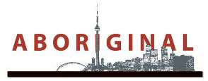

Ontario Priorities Housing Initiative
(OPHI)

Community Rental Housing Program Guidelines
2021
Table of Contents
Introduction 4

Ontario Priorities Housing Initiative (OPHI) 4

Program Objectives 5

Program Timelines 5

Capital Funding Components 5
Eligibility Criteria Projects 5
Eligibility Criteria Units 6
Eligibility Criteria Proponent 6
Affordability Criteria and Rents 7
Eligible Tenants, Tenant Income Thresholds and Verification 8
Funding 8
Project Submission Process 9
Project Approval Process 10
Contributions by Others 10
Energy Efficiency 11
Suite Meters 11

Administrative Requirements 11
Idemnification and Repayment 11
Funding Requirements -Aboriginal Rental Contribution Agreement (ARCA) 12
Reporting Requirements 12
French Language Services 12
Authority 12

Contact Information 13

Appendices

Appendix A: | Map of the GTA and Municipalities

Introduction

Miziwe Biik Development Corporation (MBDC) was established in 2004 by Miziwe Biik Aboriginal Employment and Training. The mission of MBDC is to serve as a vehicle for the economic advancement and self-sufficiency of the Aboriginal community in the Greater Toronto Area (GTA). To this end, MBDC engages in activities that focus on affordable housing including rental development, homeownership and supportive housing as well as access to business development and training and other opportunities that will economically advance the members of the GTA Indigenous community.

MBDC represents the community desire for an Indigenous-controlled institution as the delivery agent of housing initiatives including programs and funding. As determined in the Greater Toronto Area Aboriginal Housing Consultation 2008 Final Report (http://www.mbdc.ca/acrobat/abconsultfinal.pdf) MBDC is:
- an effective and efficient agency which operates in an open and transparent manner;
- respects Indigenous cultures and values, operates in conjunction with Miziwe Biik Aboriginal Employment and Training, which has a strong history of financial accountability to the community and all levels of government;
- strengthens the capacity of the Indigenous community in the GTA;
- provides a solid foundation for future investment and;
- offers an excellent platform for linking and leveraging housing with a variety of non-housing Indigenous supports and services.

Ontario Priorities Housing Initiative (OPHI)

OPHI is modeled after previous successful housing programs and will be administered by MBDC in the GTA through the following programs:
- Rental Housing
- Homeownership
- Rental Assistance
- Housing Support Services

The OPHI yearly allocations for MBDC are as follows:
Funding by Fiscal Year for OPHI
Year 1  2019-20 | Year 2  2020-2021 | Year 3  2021-2022
$2,106,200 | $1,091,200 | $1,698,700

Program Objectives

The OPHI rental component will increase the supply of community rental housing for off-reserve Indigenous households on, or eligible to be on, social housing waiting lists. It will also ensure that safe, adequate and affordable rental housing is available to the GTA Indigenous community.

Program Timelines

MBDC may issue Request for Proposals (RFPs) for the OPHI at any time during the year however, partnership/contribution agreements between MBDC and service/housing providers must be signed no later than December 20th of each funding year.

Capital Funding Components

Eligibility Criteria – Projects

Eligible projects must be non-profit/municipal/co-operative developments or partnerships, and be one of the following:
- New construction, including additions and extensions;
- Acquisition and, where required, rehabilitation of existing residential buildings to maintain or increase the affordable rental housing stock; or,
- Conversion of non-residential buildings or units to purpose-built rental buildings/units

Projects that are not eligible include:
- Projects proposed by private sector proponents without non-profit/municipal/co-operative partnership*
- Secondary suites in owner-occupied housing
- Nursing and retirement homes
- Shelters and crisis care facilities
- Owner-occupied housing
- Student residences

*Canada Mortgage and Housing Corporation has made available other programs – for example, the National Housing Co-Investment Fund – to support the development of affordable units by private developers. The Ministry is interested in focusing OPHI funding on the development of community housing that will provide longer-term public benefit.

Eligibility Criteria – Units

Units must be modest in size and amenities relative to other housing in the community. Units are expected to be self-contained. Proponents who wish to develop congregate living buildings (rooms with shared living spaces) for supportive housing may be eligible for program funding and should provide a rationale in order to receive funding.
The following provincial minimum and average size requirements must be used as a guideline for new construction projects.
 | Bachelor | 1 Bedroom | 2 Bedroom | 3 Bedroom | 4 Bedroom
Minimum | 40.0 m² | 48.7 m² | 60.4 m² | 83.6 m² | 102.2 m²
Average | 41.8 m² | 55.0 m² | 67.4 m² | 92.9 m² | 109.2 m²

Up to 30% of the total available space may be used for non-residential purposes, including common areas and services used directly with the residential accommodation such as office space for support services providers.

Eligibility Criteria – Proponent

Funding submissions will only be accepted from non-profit Indigenous Housing/Service Providers (IHSP’s) or, from partnerships between a non-profit IHSP and another organization, when the non-profit IHSP has a 51% or greater stake in the proposed development. With respect to partnerships between Indigenous and non-Indigenous groups, it must be demonstrated that the project is, and will remain, within Indigenous control and all policy, governance, and decision-making matters must reside with the Indigenous partner. IHSPs must have a permanent office located within the GTA, and in partnerships between Indigenous and non-Indigenous groups, the Indigenous partner must be based in the GTA.

IHPs must be recognized Indigenous organizations in which Indigenous people are key decision-makers, such as Board members and/or senior management. By definition, IHSPs are organizations whose Letters Patent identify that they have a mandate to provide housing/services to Indigenous people, are accountable to the Indigenous community by having a Board of Directors elected by, and from, the Indigenous community, and have Indigenous membership and Indigenous staff. Proponents seeking funding under the OPHI will be asked to verify that they meet the above definition.

Private, for-profit organizations are not eligible for funding under the OPHI unless they partner with a non-profit IHSP in accordance with the conditions set out above. For example a private, for-profit partner may serve as the builder/developer of a project and upon completion the IHSP then purchases all or some units from the for-profit partner. This is sometimes referred to as a ‘turn key’ type of arrangement. In a ‘turn key’ partnership arrangement, the for-profit partners retain no ongoing ownership stake in the project.

Please note that MBDC does not advocate for or prefer any particular type of partnership arrangement. Proponents must decide for themselves if forming a partnership would strengthen their development concepts and, if so, should structure their partnership relationships accordingly.

Affordability Criteria and Rents

Canada Mortgage and Housing Corporation (CHMC) Average Market Rent’s (AMR) are available on the Ministry of Municipal Affairs and Housing (MAH) website at www.mah.gov.on.ca and updated annually.

MBDC also provides current CMHC AMR’s at www.mbdc.ca.

Approved capital projects must remain affordable for a minimum period of 20 years. Affordability is defined as having an average rent for the project that is at or below 80% of CMHC AMR at the time of occupancy. Average rent is calculated using actual rents paid by tenants and includes any rent supplements.
While individual unit rents may be set above or below the 80% threshold, in no instance shall an OPHI-funded Rental Housing unit have a rent that is greater than the Canada Mortgage and Housing Corporation Average Market Rent for the area.
Projects may include both OPHI Rental Housing and market units, but only units with rents that meet affordability requirements will receive OPHI funding.
Rent supplements may be utilized to provide a greater depth of affordability to tenants. Total rent received by proponent (tenant-paid or Rent Supplements) must not exceed 100% of the CMHC AMR. In addition, the total rent received by proponent as described above will be used to calculate the weighted average rent in a project.

Projects may include both OPHI funded units and market units, but only units with rents that meet the affordability requirements of the OPHI will receive funding through this program.
Rent increases under the OPHI must be in accordance with the Residential Tenancies Act, 2006 (RTA) rent increase guideline. Units must remain at or below 80% of CMHC AMR.
Rent charged for eligible units must include the utility costs of heat, hydro and water/wastewater.

Eligible Tenants, Tenant Income Thresholds and Verification

Projects must meet the following “Eligible Tenant” criteria:
- Tenant(s) must be considered “Indigenous” or “Indigenous Households”;
- Tenant(s) must be on, or eligible to be on, an existing social housing waiting list;
- At the time of occupancy, the eligible tenant must be paying a minimum of 20% of their income on rent.

For the purpose of these Guidelines, “Indigenous” is defined as an individual that is either status or non-status Indian or First Nation or Métis or Inuit and “Indigenous Households” are defined as multiple tenants that are Indigenous and/or a family whereby at least one individual family member is Indigenous.
Projects must demonstrate an income verification method acceptable to MBDC that ensures households in need are targeted.

Funding

Program funding for the Rental Housing component is provided as a forgivable capital loan.

The OPHI Rental Housing component will fund up to 75% of the pro-rated share of the capital costs of the affordable units. Total capital costs include land, financing, hard (construction) and soft costs but less any HST rebates.

Projects must be financially viable from a construction cost and on-going operating context and demonstrate value for money. Units must be modest relative to other housing in the community.

Funding will become available to approved projects based on completion of program milestones and will be advanced to projects based on standard construction milestones and program compliance. Please see chart below for program milestones.

Project Type | First Milestone | Second Milestone | Third Milestone
New Construction | 50% upon signing CA and confirmation of registration of security | 40% at confirmation of structural faming completion | 10% at confirmation of occupancy & submission of Initial Occupancy Report
Acquisition/ Rehabilitation | 50% upon signing CA and confirmation of registration of security | 40% at confirmation of 50% completion of project | 10% at confirmation of occupancy & submission of Initial Occupancy Report

Project Submission Process

MBDC will solicit proposals through an open, competitive process and select rental housing projects to recommend to the Ministry for funding approval.

Recommended projects shall:
- Be approved by the MBDC Board of Directors based on board procurement practices;
- Be able to sign a Contribution Agreement no later than December 31 of each program year.
- Be able to start construction within 120 days after signing a Contribution Agreement and be completed within four years.
- Be financially viable from a construction and operating cost perspective – based on MBDC confirmation
- Meet the current Ontario Building Code and Canadian Environment Assessment Act, 2012 requirements.
- Have rents that on average for the project are at or below 80% of the Canada Mortgage and Housing Corporation Average Market Rent for the community or as approved by the Ministry for a minimum of 20 years (see “Affordability Criteria and Rents” on page 7 for additional details).
- Provide the required equity, if applicable – 4% for partnerships between private sector and non-profit organizations; 0% for non-profit organizations.
- Are projected to maximize achievable reductions in energy consumption and greenhouse gas emissions relative to minimum requirements (i.e. meet or exceed the current National Energy Code and Ontario Building Code requirements for new construction; for renovations/repairs, maximize the achievable energy savings where possible when planning work or retrofits).
- Have an occupancy plan in place to ensure that units will be occupied in a timely manner.

Priority consideration will be given to projects that:
- Have Contributions by Others, including the local municipality, and proponent – to be used in partnership with OPHI Rental Housing funding.
- Include family-sized (multi-bedroom) units.
- Are fully accessible and/or have units that are accessible to persons with disabilities.
- Provide community employment benefits including:
  - Work contracts for small and medium-sized businesses
  - Job creation for apprentices, Indigenous Peoples, women in construction, veterans and newcomers to Canada
- Have support service funding in place, if applicable.

Project Approval Process

Project approval will be based on construction readiness, ability to meet the program’s eligibility criteria, and alignment with the Investment Plan.

Once approved, a project will receive a Conditional Letter of Commitment (CLC) from the Ministry, which will confirm Ministry approval and outline the steps to take prior to entering into an Aboriginal Rental Contribution Agreement (ARCA) with MBDC.

The ARCA shall describe legal obligations and reporting requirements for the project (including but not limited to, use of funds, permitted encumbrances, construction and permanent insurance requirements and completion on budget within timelines without outstanding construction liens and/or work orders).

Contributions by Others

In addition to providing required equity, proponents are encouraged to provide additional contributions in order to increase the financial viability of the project and/or to provide deeper affordability.

Contributions by proponents may include: land or cash, including that from fundraising and donations.

Also, proponents may seek the reduction or waiving of other costs such as: development charges, planning approval and application fees, building permit fees, and full property tax exemptions as well as contributions of municipal grants, and municipally-owned land. Proponents may be required to enter into separate legal agreements with the municipality and/or register the municipal assistance as a charge on title to the property.

It should be assumed that proponents are responsible for the payment of all applicable municipal fees and development charges.

Energy Efficiency

MBDC encourages the use of energy efficient features in building design and ENERGYSTAR-rated products should be used when available.

Suite Meters

Mandatory suite meters must be installed in all new social and affordable rental housing units.

The Energy Consumer Protection Act, 2010 and Ontario Regulation 389/10 set out the rules for suite meter installation. For further information, please contact the Ontario Energy Board’s (OEB) Consumer Relations Centre at 1-877-632-2727 or 416-314-2455, or go to www.ontarioenergyboard.ca.

Administrative Requirements

Indemnification and Repayment

There are obligations for all OPHI parties with regard to the indemnification and recovery of government funding. Specific obligations and provisions are included in the MBDC/MHO Transfer Payment Agreement.

The Ministry has developed the Affordable Housing Program and Investment in Affordable Housing Risk Mitigation Strategies Guide (2012) that provides best practices and clarification on preventing and resolving issues with affordable housing projects that may experience difficulties. The Guide can be found at: http://www.mah.gov.on.ca/Asset9886.aspx.
In cases where an OPHI capital project encounters difficulties, the risk mitigation strategies outlined in the Guide may assist proponents and Program Administrators.

Funding Requirements –

OPHI Aboriginal Rental Contribution Agreement (ARCA)

All IHSPs that are awarded funding under the OPHI capital funding component will be required to enter into an Aboriginal Rental Contribution Agreement (ARCA), with MBDC. The ARCA outlines the roles and responsibilities of IHPs and defines the accountability framework, legal obligations, funding schedule, communications protocol and reporting requirements between IHSPs and MBDC. In addition, the ARCA governs project monitoring for OPHI funded projects for a 20-year affordability period (for mortgage). Once signed, the ARCA, and all other additional security will be registered on title to each of the project lands for which funding is provided.

Reporting Requirements

Proponents are required to submit confirmation of construction start date of projects, Initial Occupancy Report once projects are completed and occupied, as well as an Annual Occupancy Report each year.

Additionally, proponents are required to submit to MBDC an audited capital cost statement from an independent auditor(s) within three months following the initial occupancy date, or such additional time acceptable to the MBDC.

French Language Services

All IHPs providing services under the OPHI and having offices (including the offices of sub-contractors) located in or serving an area designated in the French Language Services Act, will be required to submit yearly French Language Services Report. See “Schedule A” French Language Service Report, Page 39. Designated areas under the French Language Services Act in the GTA include:

City of Toronto – All
Regional Municipality of York – City of Markham (as of July 1, 2018)
Regional Municipality of Peel – City of Mississauga; City of Brampton

Authority

The MBDC Board of Directors has the authority to recommend funding allocations to MHO. Payment to proponents will be made in keeping with the OPHI Ontario Transfer Payment Agreements. The MBDC Board of Directors has the power to delegate its authority, or a portion thereof, to the OPHI Program staff.

Contact Information

GTA Aboriginal Housing Program Office
Miziwe Biik Development Corporation
167 Gerrard Street East, 2nd Floor
Toronto, Ontario
M5A 2E4

Phone: (416) 640-4684
Fax: (416) 640-4687
Email: lorna.lawrence@mbdc.ca
Web: www.mbdc.ca

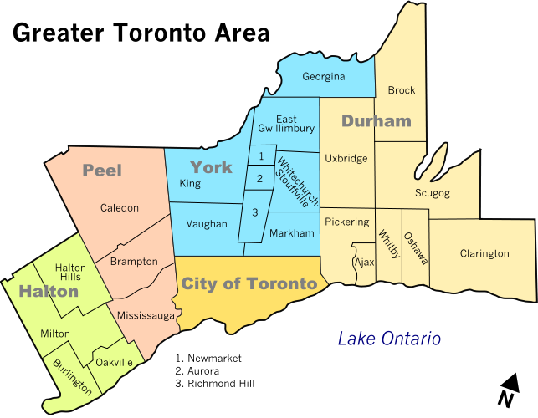
Appendix A:

Maps of the GTA and Municipalities

Region of Durham

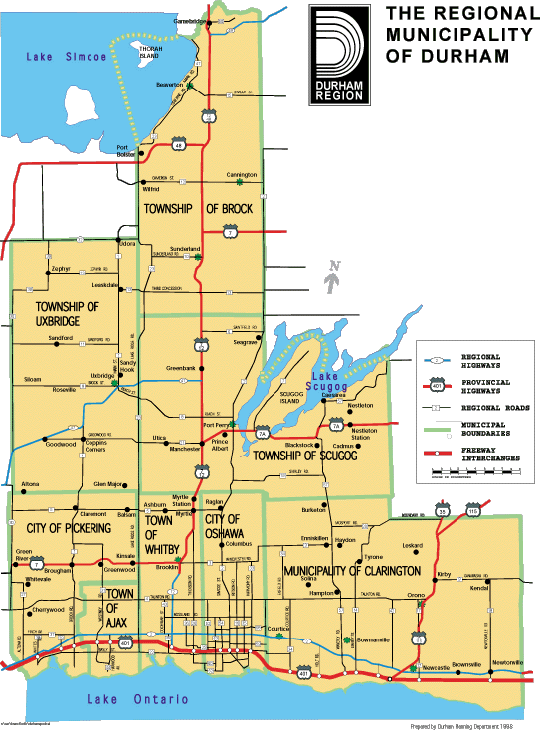

Region of Halton

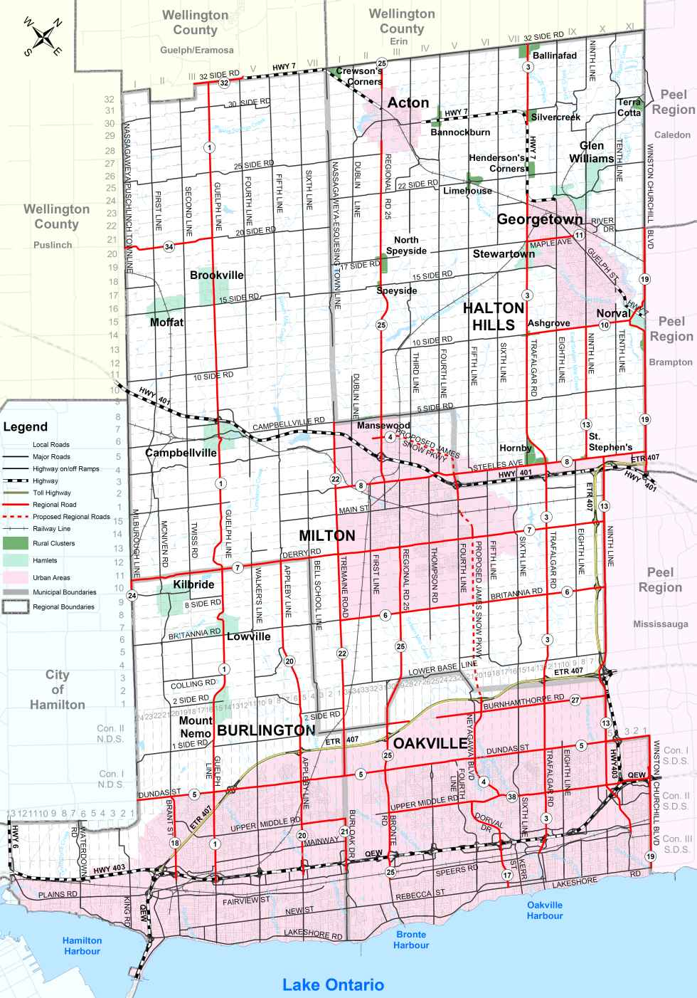

Region of York
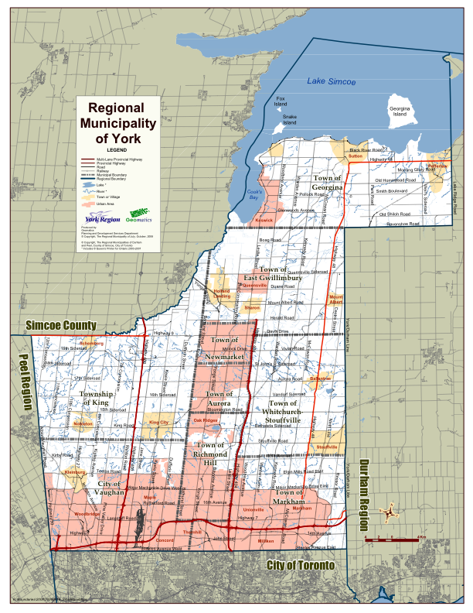

Region of Peel

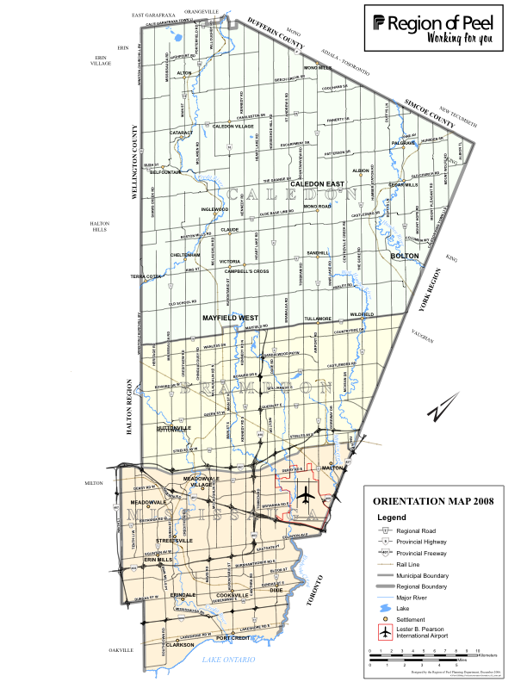

City of Toronto
